**1 INTRODUCTION**

**1.1Overview**

**An info graphic is a collection of imagery, data visualizations like pie charts and bar graphs, and minimal text that gives an easy-to-understand. As in the example below, info graphics use striking, engaging visuals to communicate information quickly and clearly.**

**1.2 Purpose**

**Info graphic delivers data and analysis in a way that helps your audience digest and understand information easily in a visually pleasing format.**

**2 Problem Definition & Design Thinking**

**2.1 Empathy map**

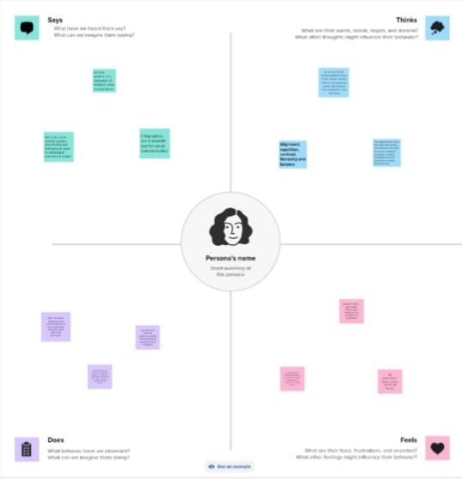

**2.2 Ideation & Brainstorming map**

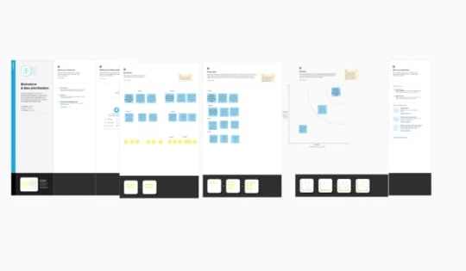

**3 Result**

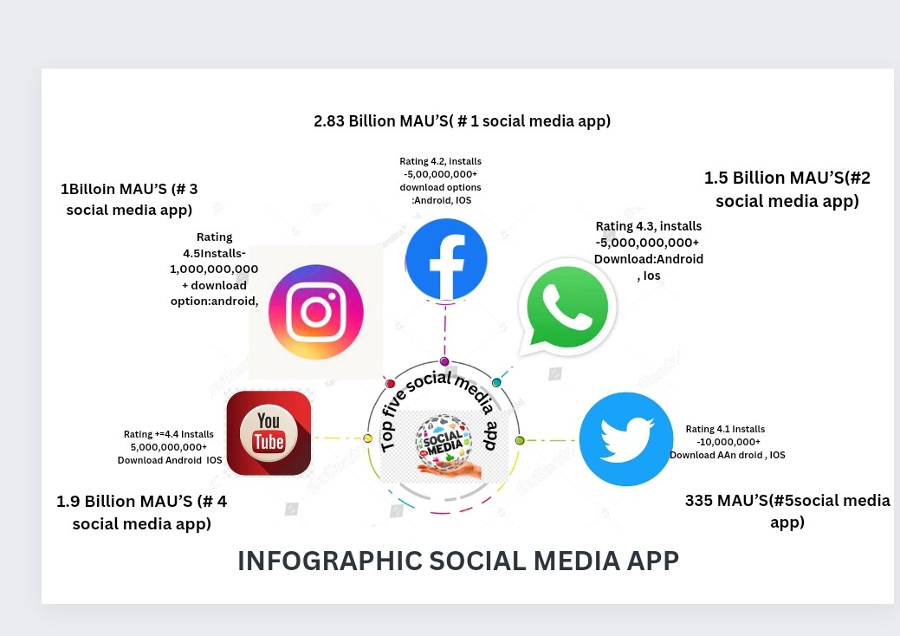

**Info graphic social media result the people are using in the top 5 social media apps, they are facebook, whatsapp, instagram, youtube, twitter, some people are using facebook rating 4.2 installs-5,00,000,000+ download options android IOS, (2.83 billion using facebook) some people are using whatsapp rating on 4.3 installs-5,00,000,000+ download android IOS, (1.5 billion using whatsapp) some people are using instagram rating 4.5 intalls-1,000,000,000+ download options android IOS, (1 billion using instagram) some people are using youtube rating+=4.4 intalls 5,000,000,000+ download android IOS, (1.9 billion using youtube) some people are using twitter rating 4.1 intalls 10,000,000+ download android IOS, (335 people using twitter)**

**4 Advantages & Disadvantages**

**4.1 Advantages**

* **Canva offers a variety of templates and elements**
* **Templates can be altered to be more custom**
* **Canva offers a professional look.**

**4.2 Disadvantages**

* **Cannot download the “Raw” file to your computer the free version is limited.**
* **You are unable to move one design to another design.**

**5 Applications**

**I have used mural application and canva application.**

**6 Conclusions**

**We have created info graphic with the help of canva.**

**7 Future Scope**

**We were planning to join the graphic designing course.**